Section I
Total Marks (75)

Part A
Total marks (15)
Attempt Questions 1-15
Allow about 30 minutes for this part

INSTRUCTIONS
Use the multiple choice answer sheet on page 6.
Select the alternative A, B, C or D that best answers the question. Fill in the response oval completely.

Sample 2+4= (A) 2 (B) 6 (C) 8 (D)9

A  B  C  D 

If you think you have made a mistake, put a cross through the incorrect answer and fill in the new answer.

A  B  C  D 

If you change your mind and have crossed out what you consider to be the correct answer, then indicate this by writing the word correct and drawing an arrow as follows:

correct

A  B  C  D 

________________________________________________________________________________

Student Number …………………………

1. Which of these substances is detectable using AAS?

(A) Scandium
(B) Sulfate
(C) Sulfur
(D) Sulfur dioxide

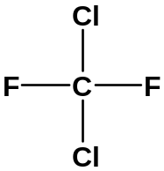2.

Which is the correct systematic name for the above structure?

(A) dichlorofluoromethane
(B) dichlorodifluoromethane
(C) 1,1–difluoro–1,1–dichloromethane
- 2,4–dichloro–1,3–difluoromethane

3. Fritz Haber and many other chemists worldwide were actively working to solve the problem
of making ammonia by direct synthesis. What was the reason for this great interest
ammonia?

(A) Ammonia was unsurpassed as a coolant in refrigerators.
(B) Ammonia was essential for making high explosives for World War II.
(C) Ammonia was a very effective cleaning agent, but too expensive for household use.
(D) Ammonia was a possible solution to a projected global problem of soil infertility.

4. Which metal ion cannot be identified by a flame test?

(A) Ba²⁺_{(aq)}
(B) Ca²⁺_{(aq)}
(C) Cu²⁺_{(aq)}
(D) Pb²⁺_{(aq)}

5. A fruit cannery factory discharges untreated wastes, consisting largely of rinse water and
fruit pulp, into a nearby stream. What effect will this have on the water?

(A) The level of dissolved oxygen will increase.
(B) Turbidity would decrease.
(C) The biochemical oxygen demand will increase.
(D) The hardness of the water will increase.

6. Which oxide does not produce an acid in water?

(A) N₂O
(B) NO₂
(C) SO₂
(D) SO₃

- A certain solution has ten times the hydrogen ion concentration of a solution of pH = 8. What is the pH of the more acidic solution?

(A) 0.8
(B) 4
(C) 7
(D) 9

- 10 mL of a 0.1 mol L⁻¹ hydrochloric acid solution is added to 20 mL of a 0.1 mol L⁻¹ nitric acid solution. What is the pH of the mixture?

(A) 1
(B) 0.5
(C) -0.5
(D) 2

- What volume of carbon dioxide (measured at 25 ⁰C & 100kPa) is formed from the reaction of 25.0 g calcium carbonate with excess hydrochloric acid?

(A) 24.79 L
(B) 3.1 L
(C) 12.4L
(D) 6.2 L

- When carbon dioxide is dissolved in water the following equilibrium occurs:

CO₂(g) + H₂O(l) H₂CO₃(aq)

The process is exothermic. What happens to the solubility of carbon dioxide if the solution is
heated?

(A) increases
(B) decreases
(C) remains constant, solubility is only affected by pH
(D) increases then decreases slightly.

11. How is ethylene produced industrially?

(A) extracted from crude oil
(B) fractional distillation of crude oil
(C) cracking of the low molecular weight fraction of crude oil
(D) fermentation of glucose

Student Number …………………………

12. Low density polyethylene is produced using an organic peroxide initiator.
Given below is a randomly numbered list of the steps involved in its production:

1. Monomer radicals react with doubly bonded carbon atom of another molecule
2. Free radical organic peroxide initiator react with the doubly bonded
carbon atom in a monomer
3. Organic peroxide splits to form free radical
4. Activated monomer radicals form
5. Chain growth stops if free radicals combine together
6. Chain builds and lengthen

Choose the correct sequence from among the choices given below

(A) 2 → 3 → 4 → 1 → 5 → 6
(B) 3 → 2 → 4 → 1 → 6 → 5
(C) 4 → 3 → 1 → 2 → 6 → 5
(D) 3 → 1→ 2 → 4 → 5 → 6

13. Cellulose is a natural biopolymer composed of glucose monomers. Which glucose structures
in the diagram are required to form a strand of cellulose with six glucose units:

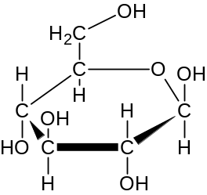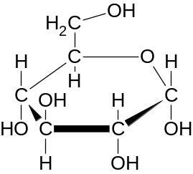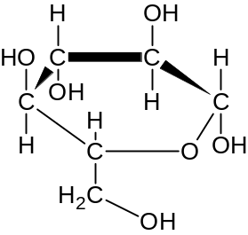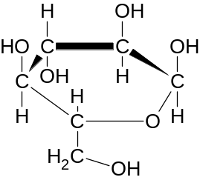

Structure 1 Structure 2 Structure 3 Structure 4

(A) 1, 4, 1, 4, 1, 4
(B) 2, 3, 2, 3, 2, 3
(C) 1, 3, 1, 3, 1, 3
(D) 2, 4, 2, 4, 2, 4

14. The molar heat of combustion of ethanol is 1364 kJ mol⁻¹. How much water at 20 ⁰C can be
heated to 90 ⁰C if 20.0 g of ethanol is completely combusted to carbon dioxide and water?

(A) 2.02 g
(B) 2.02 kg
(C) 20.2 g
(D) 20.2 kg

15. A student undertook a first hand investigation to determine the reactivity of cyclohexene
Which test reagents and results are appropriate for this experiment?

Conditions | A | B | C | D
Reagent used | bromine water | chlorine gas | bromine water | ethanol
To increase validity | protect from light | control the temperature | repeat the experiment | repeat the experiment
Result observed | decolourised | odourless gas released | purple solution formed | sweet smelling gas released

Student No. ……………….

Section A Mark -----/15

Multiple Choice Answer Sheet

1. A  B  C  D 

2. A  B  C  D 

3. A  B  C  D 

4. A  B  C  D 

5. A  B  C  D 

6. A  B  C  D 

7. A  B  C  D 

8. A  B  C  D 

9. A  B  C  D 

10. A  B  C  D 

11. A  B  C  D 

12. A  B  C  D 

13 A  B  C  D 

14. A  B  C  D 

15. A  B  C  D 

JAMES RUSE AGRICULTURAL HIGH SCHOOL
2004 CHEMISTRY TRIAL HSC EXAM Student Number …………………………

Section I (continued)

Part B - 60 marks
Attempt Questions 16 -27
Allow about 1 hour and 45 minutes for this part

Answer the questions in the spaces provided
Show all relevant working in questions involving calculations

Question 16 (6 marks) MARKS

The aim of a Prac Test was the identification of four unknown solutions using four test
solutions. A student records these test results (R = reaction; NR = no reaction) …

 |  | Unknown Solutions
 |  | W | X | Y | Z
Test Solutions | HNO₃ | NR | NR | NR | R
Test Solutions | H₂SO₄ | R | R | NR | R*
Test Solutions | Ba(NO₃)₂ | NR | NR | R* | NR
Test Solutions | AgNO₃ | R | R* | NR | NR

The student was told that the unknowns were potassium sulfate, barium chloride,
sodium carbonate and calcium chloride.

(a) Identify the compounds which match–up with unknowns W, X, Y and Z. 3

W =

X =

Y=

Z=

(b) Write balanced chemical equations for the three asterisked reactions (R*) in the
table above. 3

......................................................................................................................................

......................................................................................................................................

......................................................................................................................................

MARKS

Question 17 (5 marks)

The National Australian Standard for sulfur in petrol is 500 ppm maximum.

(a) Calculate the mass of sulfur in one litre of petrol weighing 714 grams.
(Assume 500 ppm sulfur) 1

....................................................................................................................................

.................................................................................................................................…

.................................................................................................................................…

................................................................................................................................….

(b) Calculate the volume of sulfur dioxide produced by the complete combustion of
one litre of petrol at 100 kPa and 25°C. 2

...................................................................................................................................

...................................................................................................................................

................................................................................................................................…

................................................................................................................................….

(c) Write a balanced chemical equation showing sulfur dioxide producing acid rain and
name the acid formed. 2

...................................................................................................................................

……………………………………………………………………………………….

Student Number …………………………

Question 18 (8 marks) MARKS

A Year 9 student does a research project testing the BOD of a polluted stream near
his home. He writes this entry in his science journal…

I got a bucketful of stream water and carried it home. It looked a bit murky so
I decided to filter it through a plastic funnel using paper towel for filter paper.
It worked well and cleared up the water.

I measured out exactly one litre of stream water and poured it into a 2 litre
beaker. I then measured the dissolved oxygen using a borrowed oxygen–sensitive
electrode and recorded the reading. I then placed the beaker on a shelf underneath
the awning on the back veranda.
A week later I measured the dissolved oxygen again and recorded the reading.

(a) The procedural errors made by the student will greatly affect the validity
of the BOD result. Identify two errors made and provide the correct
procedures he should have followed. 2

Student’s Error | Correct Procedure

(b) The student suspects that the polluted stream is subject to eutrophication.
Identify two (2) chemical species which he could test for as proof of eutrophication. 2

……………………………………………………………………………………….

…………………………………………………………………………………………

Question 18 continues next page
Question 18 continued
MARKS

(c) The student decides to test the stream water for total dissolved solids without
using a TDS meter. Describe a simple test procedure he should follow and the
data he should collect and record 2

…………………………………………………………………………………………….

…………………………………………………………………………………………….

…………………………………………………………………………………………….

…………………………………………………………………………………………….

……………………………………………………………………………………………..

(d) High tech microscopic membrane filters are a means of cleaning up some
polluted water.

(i) Identify the composition of the membranes, i.e. what are they made of? 1

…………………………………………………………………………..

……………………………………………………………………………

(ii) Membrane filters can capture germs but not heavy metal ions.
Describe the physical basis of how these filters work. 1

……………………………………………………………………………..

……………………………………………………………………………..

........................................................................................................................

Question 19 (3 marks)

In a titration to find the concentration of sulfuric acid solution, 28.6 mL of
0.176 mol L⁻¹ sodium hydroxide solution was required to neutralise 25.0 mL of
sulfuric acid solution. Calculate the concentration of the sulfuric acid solution in
mol L⁻¹. 3

............................................................................................................................................

............................................................................................................................................

............................................................................................................................................

............................................................................................................................................

............................................................................................................................................

............................................................................................................................................
MARKS
Student Number …………………………
Question 20 (3 marks)

(a) Describe using a balanced chemical equation the formation of an ester from the
reaction of C₃H₇COOH (l) with C₂H₅OH (l) 2

...............................................................................................................................................

(b) Name the ester. 1

...............................................................................................................................................

Question 21 (4 marks)

Identify examples of naturally occurring acid and base.. In the table below record their
names and their chemical formulae. 4

ACID | Chemical Formula
.
BASE | Chemical Formula

Question 22 (3 marks)

Some commercial baking powders use sodium pyrophosphate (Na₂H₂P₂O₇) and sodium
hydrogen carbonate (NaHCO₃) to make cakes rise when baked.

The reaction that occurs can be described by the following equation (states excluded)

NaHCO₃ + Na₂H₂P₂O₇ Na₃HP₂O₇ + H₂O + CO₂

(a) Write the net ionic equation for this reaction, including states. 1

...........................................................................................................................................

(b) From this net ionic equation, write the formula for a species behaving as a
Bronsted-Lowry acid. 1

............................................................................................................................................

(c)What is the conjugate base of the acid species identified in (b)? 1

.............................................................................................................................................
Question 23 (7 marks)

An investigation to determine the concentration of acetic acid in two brands of domestic
vinegar was carried out. Standard sodium hydroxide solution was used to titrate equal volumes
of Brand A and Brand B. The results of these titrations are shown
below.
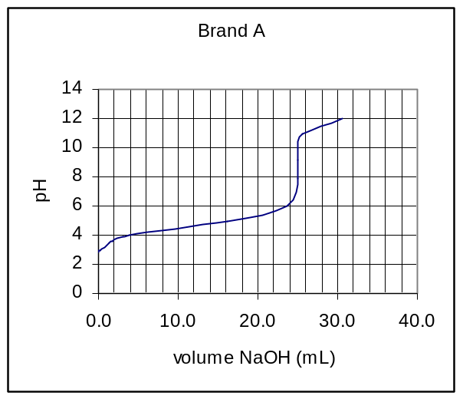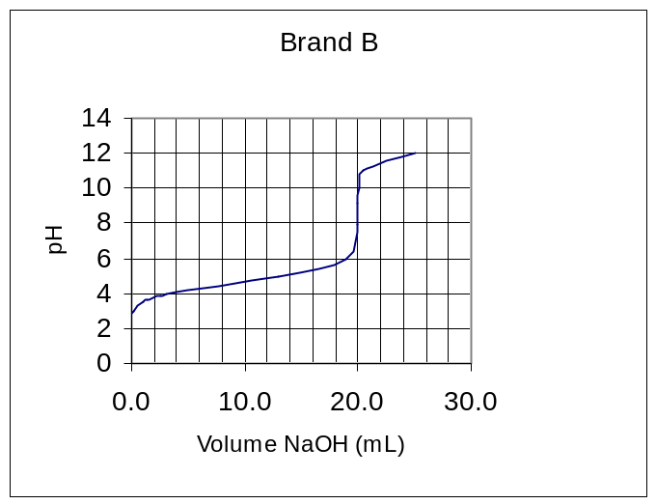

(a) Explain the procedure that can generate these titration curves. 3

...................................................................................................................................................

....................................................................................................................................................

...................................................................................................................................................….

.....................................................................................................................................................…

................................................................................................................................………………

................................................................................................................................……………….

................................................................................................................................……………….

(b) Identify the solution used to rinse the pipette before its final use. 1

..................................................................................................................................................

(c) Which brand (A or B) had the higher concentration of acetic acid? Give a reason. 1

..................................................................................................................................................

..................................................................................................................................................

(d) Is the salt produced by this neutralisation reaction acidic, basic or neutral? Write a net ionic
equation to support your answer. 2

...................................................................................................................................................

...................................................................................................................................................
Student Number …………………………
MARKS
Question 24 (5 marks)

(a) Examine the following flowchart showing the conversion of cellulose to ethylene.
cellulose

Process 1
glucose

Process 2

Substance 3

Process 3

ethylene

(i) Name substance 3……………………………………………………………. 1

(ii) Write a balanced equation for Process 2

………………………………………………………………………………….. 1

(iii) Write a balanced equation , including the catalyst for Process 3

……………………………………………………………………………………… 1

(b) Discuss the potential of cellulose as a raw material for building petrochemicals in
terms of its structure and in terms of the energy requirement of a possible process
given in (a) above 2

……………………………………………………………………………………………

……………………………………………………………………………………………

……………………………………………………………………………………………

……………………………………………………………………………………………

................................................................................................................................………

................................................................................................................................……….

MARKS

Question 25 (2 marks)

Write the details on the property and use of the polymer poly(vinyl chloride) 3

Common monomer name | vinyl chloride
Polymer name
(systematic)
Polymer property

Polymer use related to property

Question 26 (4 marks)

Compare a named transuranic element and a named commercial radioisotope in terms of their
production 4

………………………………………………………………………………………………

………………………………………………………………………………………………

………………………………………………………………………………………………

………………………………………………………………………………………………

………………………………………………………………………………………………

………………………………………………………………………………………………

................................................................................................................................………….

................................................................................................................................…………
Student Number …………………………
MARKS
Question 27 (9 marks)

(a) Draw a simple, neat well-labelled diagram of a dry cell OR a lead-acid cell. In your
diagram, you should indicate : 4
(i) the direction of flow of electrons
(ii) the cathode, the anode and the electrolyte

(b) Evaluate the dry cell or the lead acid cell in comparison to ONE of the following:
- button cell
- fuel cell
- vanadium redox cell
- lithium cell
- liquid junction photovoltaic device
in terms of chemistry and environmental impact. 5

………………………………………………………………………………………………………

……………………………………………………………………………………………………….

………………………………………………………………………………………………………..

………………………………………………………………………………………………………..

…………………………………………………………………………………………………………

…………………………………………………………………………………………………………

………………………………………………………………………………………………………….

………………………………………………………………………………………………………….

………………………………………………………………………………………………………….

………………………………………………………………………………………………………….

................................................................................................................................……………………..

Section II

25 marks

Attempt Question 28
Allow about 45 minutes for this section.

Answer the question in a writing booklet provided
Show all relevant working in questions involving calculations

Question 28 MARKS

(a) (i) Outline two uses of sulfuric acid in industry 2

(ii) Describe, using examples and equations the reactions of sulfuric acid
acting as: 4
(1) an oxidising agent
(2) a dehydrating agent

(b) The dissociation of nitrosyl chloride into nitric oxide and chlorine takes place
according to the equation:

2 NOCl (g)  2 NO (g) + Cl₂ (g)

Varying amounts of the three gases were placed in a container and allowed to
come to equilibrium at two different temperatures. The equilibrium
concentrations of the three gases obtained are tabulated below.

Temperature, ⁰C | Concentrations (mol L⁻¹)
Temperature, ⁰C | NOCl | NO | Cl₂
230 | 2.33 x 10⁻³ | 1.46 x 10⁻³ | 1.15 x 10⁻²
465 | 3.68 x 10⁻⁴ | 7.63 x 10⁻³ | 2.14 x 10⁻⁴

(i) Calculate the equilibrium constant K, for the reaction at 230⁰ C . Show
relevant working. 3

(ii) The equilibrium constant at 465 ⁰C is 9.20 x 10⁻². Does the different
value for the equilibrium constant indicate that the reaction is
endothermic or exothermic? Explain your answer. 2

(iii) The energy change involved in the above reaction is + 38kJ per mole
of nitrosyl chloride decomposed. Rewrite the equation for the
dissociation of one mole of nitrosyl chloride and complete the
description of the reaction by specifying ΔH (sign and magnitude)
for the reaction you have written. 1

Question 29 continues next page, Turn the page over.
Student Number …………………………

MARK

(c) Describe two potential environmental issues associated with the extraction of
sulfur from mineral deposits. 2

(d) Describe the reactant conditions necessary for the production of SO₃ from SO₂. 3

(e) Explain the difference between galvanic cells and electrolytic cells in terms of
energy requirement. 2

(f) (i) Write the full formulae equation for the production of sodium hydroxide
from sodium chloride. 1

(ii) The membrane process is one electrolytic method used to extract sodium
hydroxide from sodium chloride. Describe the membrane process and
explain, in terms of environmental considerations, why it is the industrially
preferred method of extraction. 5

END 

